P2 PENGANTAR DESAIN PRODUK

FROM ART TO PART
FEASIBILITY ANALISYS

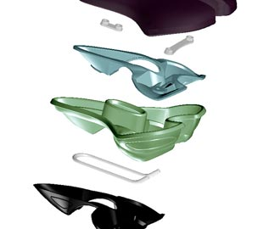

Daftar Pustaka
1. Lawson, Bryan. 1990. How Designers Think. Butterworth Architecture.
2. Pena, Parshall. 2006. Problem Seeking – Fourth Edition.
HOK. Pub.
3. Roozenburg, N.F.M. & J. Eekels. 1995. Product Design: Fundamentals and Methods. John
Wiley & Sons.

