 |  | COURSE PROGRAM OF ACADEMIC YEAR 2018/2019
 |  | ENGLISH LANGUAGE EDUCATION DEPARTMENT
 |  | ESA UNGGUL UNIVERSITY
Course |  |  | : | Basic Listening |  |  | Course Code |  | : | PBI 161
Prerequisite course |  |  | : | - |  |  | Credit |  | : | 3 SKS
Lecturer |  |  | : | Noni Agustina, M.Pd. |  |  | Lecturer Code |  | : | 7218
Time Allocation |  |  | : | 14 session X 150 minutes
Learning Achievement |  |  | : | - Understand general and specific information on various genres  - Identify what should do or not do based on the information  - Recognize speakers’ attitudes in conversation  - Summarize main ideas
SESION | LEARNING OUTCOME |  | INSTRUCTIONAL MATERIALS |  | TEACHING ACTIVITIES | REFERENCES |  | ACHIEVEMENT INDICATORS
1 | Students are able to recognize language elements in the songs. |  | - Course outline  - Class regulations  - Introduction to the Course  - Songs |  | Lecturing and discussion  Media : class, computer, LCD and whiteboard | Course Outline  1. Tanka and Baker. 2010. Interactions Listening/Speaking.4th edition.Singapore: McGraw-Hill  2. Hanreddy and Whalley. 2006. Mosaic Listening/speaking.4th edition. Singapore: McGraw-Hill |  | - Recognize language elements  - Analyze language elements in the songs
2-3 | Students are able to listen for phonological details. |  | - Sound  - Stress  - Intonation |  | Lecturing and discussion | 1. Tanka and Baker. 2010. Interactions Listening/Speaking.4th edition.Singapore: McGraw-Hill  2. Hanreddy and Whalley. 2006. Mosaic Listening/speaking.4th edition. Singapore: McGraw-Hill |  | 1. Identify sound, stress, and intonation  2. Reproduce utterances based on the texts heard  3. Identify the meanings of utterances with different stress and intonation
4 | Students are able to identify main and supporting details and speakers’ attitudes and feelings in short texts. |  | Short texts (dialogues) |  | Lecturing and discussion  Media : computer, speaker, LCD and whiteboard | 1. Helgesen, et.al. 2007. Practical English Language Teaching. Listening. NY: McGraw-Hill.  2. Tanka and Baker. 2010. Interactions Listening/Speaking.4th edition.Singapore: McGraw-Hill. |  | - Recognize main and supporting details  - Recognize speakers’ attitudes and feelings
5 | Students are able to identify specific information and make inferences. |  | Dialogues and narrative texts |  | Lecturing and discussion  Media : computer, speaker, LCD and whiteboard | 1. Helgesen, et.al. 2007. Practical English Language Teaching. Listening. NY: McGraw-Hill.  2. Tanka and Baker. 2010. Interactions Listening/Speaking.4th edition.Singapore: McGraw-Hill. |  | - Recognize specific information  - Use information to make inferences
6 | Students are able to identify speakers’ opinions and attitudes whether they are stated implicitly and explicitly in monologues. |  | Descriptive and narrative texts |  | Information inference, discussion and lecturing  Media : computer, speaker, LCD and whiteboard | 1. Helgesen, et.al. 2007. Practical English Language Teaching. Listening. NY: McGraw-Hill.  2. Tanka and Baker. 2010. Interactions Listening/Speaking.4th edition.Singapore: McGraw-Hill. |  | - Recognize speakers’ attitudes and opinions
7 | Students are able to identify the communicative functions of utterances based on situations, participants, and goals. |  | Dialogues |  | Discussion and lecturing  Media : computer, speaker, LCD and whiteboard | 1. Helgesen, et.al. 2007. Practical English Language Teaching. Listening. NY: McGraw-Hill.  2. Tanka and Baker. 2010. Interactions Listening/Speaking.4th edition.Singapore: McGraw-Hill. |  | - Identify the communication functions of the dialogues  - Recognize the settings, participants, and goals in the dialogues
8 | Students are able to make connections between events and facts.  Students are able to identify cause and effect relationship |  | Instructions |  | Discussion and lecturing  Media : computer, speaker, LCD and whiteboard | 1. Helgesen, et.al. 2007. Practical English Language Teaching. Listening. NY: McGraw-Hill  2. Tanka and Baker. 2010. Interactions Listening/Speaking.4th edition.Singapore: McGraw-Hill  3. Hanreddy and Whalley. 2006. Mosaic Listening/speaking.4th edition. Singapore: McGraw-Hill |  | - Use events and facts to make inferences  - Deduce cause and effect
9 | Students are able to understand different word classes and systems |  | Dialogues |  | Lecturing, discussion  Media : computer, speaker, LCD and whiteboard | 1. Helgesen, et.al. 2007. Practical English Language Teaching. Listening. NY: McGraw-Hill  2. Tanka and Baker. 2010. Interactions Listening/Speaking.4th edition.Singapore: McGraw-Hill  3. Hanreddy and Whalley. 2006. Mosaic Listening/speaking.4th edition. Singapore: McGraw-Hill. |  | - Classify word classes  - Describe the use of tenses (past, present, and future)
10 | Students are able to identify the main and supporting details in recorded conversation.  Students are able to infer speakers’ attitudes. |  | Long conversation |  | Lecturing, discussion  Media : computer, speaker, LCD and whiteboard | 1. Helgesen, et.al. 2007. Practical English Language Teaching. Listening. NY: McGraw-Hill  2. Tanka and Baker. 2010. Interactions Listening/Speaking.4th edition.Singapore: McGraw-Hill  3. Hanreddy and Whalley. 2006. Mosaic Listening/speaking.4th edition. Singapore: McGraw-Hill. |  | - Recognize main and supporting details  - Interpret speakers’ attitudes  - Categorize information
11-12 | Students are able to explain the information in news. |  | News |  | Lecturing, discussion, presentation  Media : computer, speaker, LCD and whiteboard | 1. Helgesen, et.al. 2007. Practical English Language Teaching. Listening. NY: McGraw-Hill  2. Tanka and Baker. 2010. Interactions Listening/Speaking.4th edition.Singapore: McGraw-Hill  3. Hanreddy and Whalley. 2006. Mosaic Listening/speaking.4th edition. Singapore: McGraw-Hill |  | - Recognize the purpose of the texts  - Identify main and supporting details  - Interpret based on information in the text  - Distinguish facts from opinions
13 | Students are able to summarize information in short texts. |  | Short texts such as documentary movies, news |  | Lecturing, Discussion | 1. Helgesen, et.al. 2007. Practical English Language Teaching. Listening. NY: McGraw-Hill |  | - Identify the goal of the texts  - Write a summary
14 | Students are able to do note-taking while listening to presentation. |  | Presentation |  | Lecturing and discussion | 1. Helgesen, et.al. 2007. Practical English Language Teaching. Listening. NY: McGraw-Hill  2. Tanka and Baker. 2010. Interactions Listening/Speaking.4th edition.Singapore: McGraw-Hill  3. Hanreddy and Whalley. 2006. Mosaic Listening/speaking.4th edition. Singapore: McGraw-Hill |  | - Identify main and supporting details  - Recognize the purpose of the texts  - Categorize information

Approved by,  Head of Study Program  Esa Unggul University  Prayogo Hadi Sulistio, M. Pd. |  |  | Jakarta, September 2018  Lecturer,  Noni Agustina, M. Pd.

ASSESSMENT

WEEK | PROCEDURE | FORM | SCORE > 77  ( A / A-) | SCORE> 65  (B- / B / B+ ) | SCORE > 60  (C / C+ ) | SCORE> 45  ( D ) | SCORE < 45  ( E ) | WEIGHT
1 | Understand the course outline and class regulation |  |  |  |  |  |  | 0
2-3 | Performance Assessment | Demonstaration | * See rubric | * See rubric | * See rubric | * See rubric | * See rubric | 10 %
4 | Performance assessment | Presentation | * See rubric | * See rubric | * See rubric | * See rubric | * See rubric | 5 %
5 | Performance assessment | Presentation | * See rubric | * See rubric | * See rubric | * See rubric | * See rubric | 5 %
6 | Performance assessment | Presentation | * See rubric | * See rubric | * See rubric | * See rubric | * See rubric | 5 %
7 | Performance assessment | Presentation | * See rubric | * See rubric | * See rubric | * See rubric | * See rubric | 5 %
8 | Performance assessment | Presentation | * See rubric | * See rubric | * See rubric | * See rubric | * See rubric | 5 %
9 | Performance assessment | Presentation | * See rubric | * See rubric | * See rubric | * See rubric | * See rubric | 5 %
10 | Performance assessment | Presentation | * See rubric | * See rubric | * See rubric | * See rubric | * See rubric | 5 %
11-12 | Performance assessment | Presentation | * See rubric | * See rubric | * See rubric | * See rubric | * See rubric | 10 %
13 | Written assessment | Essay item | * See rubric | * See rubric | * See rubric | * See rubric | * See rubric | 25 %
14 | Written assessment | Essay item | * See rubric | * See rubric | * See rubric | * See rubric | * See rubric | 25 %

Assessment Rubric

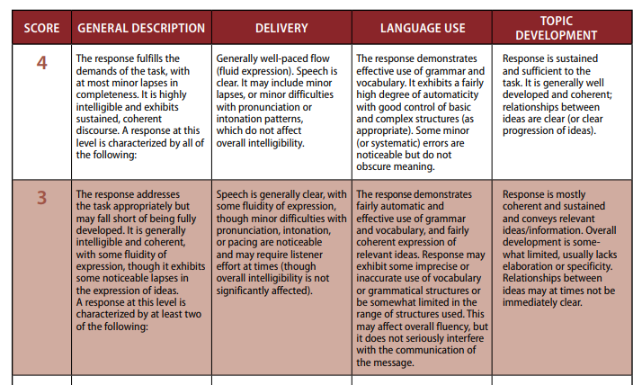

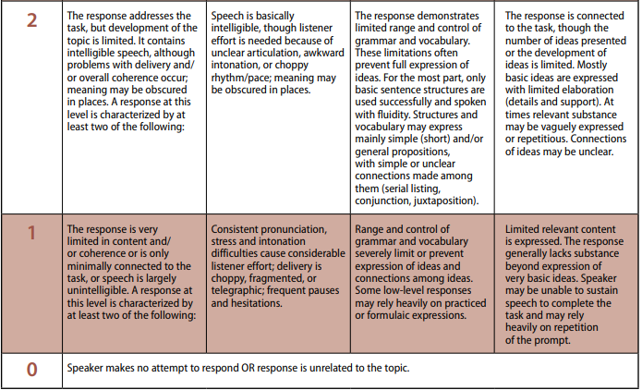

https://www.ets.org/s/toefl/pdf/toefl_speaking_rubrics.pdf

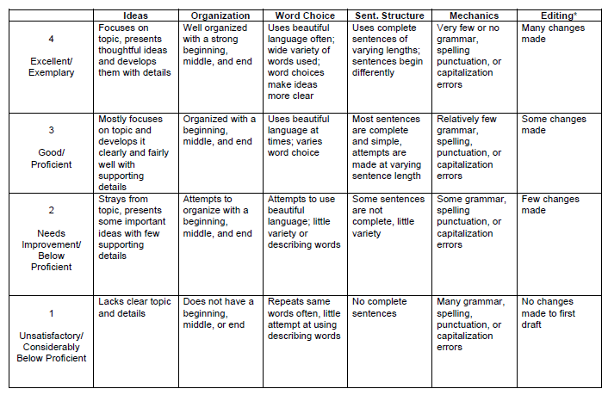
https://www.learner.org/workshops/middlewriting/images/pdf/W5LS-M-Rubric.pdf

GRADING SYSTEM COMPONENTS

Attendance | : | 10 %
Assignments and class paricipation | : | 20 %
Mid-Term Test | : | 30 %
Final Test | : | 40 %

Approved by,  Head of Study Program  Esa Unggul University  Prayogo Hadi Sulistio, M. Pd. |  |  | Jakarta, September 2018  Lecturer,  Noni Agustina, M. Pd.

