COURSE PROGRAM OF ACADEMIC YEAR 2018/2019
ENGLISH EDUCATION DEPARTMENT
ESA UNGGUL UNIVERSITY
Course |  | : | Basic Speaking |  |  | Course Code | : | PSB-171
Prerequisite |  | : | - |  |  | Credit | : | 3 SKS
Lecturer |  | : | Noni Agustina, M.Pd. |  |  | Lecturer Code | : | 7218
Time Allocation |  | : | 2 x 50 minutes
Learning Objectives |  | : | After completing this course, students are expected to be able to talk using English phrases and idioms in daily conversation, role play, retell the simple research article related to speaking skill, retell story, interview the foreigner, and have presentation effectively.
WEEK | LEARNING OUTCOMES | TOPIC/SUB-TOPICS |  | LEARNING METHOD AND MEDIA | REFERENCES |  | INDICATOR FOR ASSESSMENT
1 | Students are able to elaborate the course outline and the class regulations | - Course outline  - Class regulations |  | Method: Lecturing and discussion  Media: Projector and whiteboard | Course Outline |  | Students’ comprehension to explain course outline
2 | Students are able to do the warming-up speaking activities related to their personal life | Warming-up speaking activities |  | Method: Lecturing, discussion, demonstration  Media: Projector, whiteboard, and realia | - Ur, Penny. 2012. A Course in English Language Teaching. UK: Cambridge University Press  - Holmes, David. 2004. Speaking Activities for the Classroom. |  | Students’ performance to do the warming-up activities related to their personal life.
3 | Students are able to explore and use the English idioms in daily conversation | English idioms in daily conversation |  | Method: Presentation, lecturing, discussion, demonstration  Media: Projector, whiteboard, and video | - Gillet, Amy. 2004. Speak English Like An American. USA: Language Success Press  - Fotovatniaa , Zahra and Mehdi Goudarzib. 2014. Idiom Comprehension in English as a Foreign Language: Analysability in Focus. Procedia - Social and Behavioral Sciences, 98, pp. 499 – 503  - http://www.theidioms.com/ |  | Students’ performance to conversate using English idioms.
4 | Students are able to explore and use the English phrases in daily conversation | English phrases in daily conversation |  | Method: Presentation, lecturing, discussion, demonstration  Media: Projector, whiteboard, and video | - Gillet, Amy. 2004. Speak English Like An American. USA: Language Success Press  - Fotovatniaa , Zahra and Mehdi Goudarzib. 2014. Idiom Comprehension in English as a Foreign Language: Analysability in Focus. Procedia - Social and Behavioral Sciences, 98, pp. 499 – 503  - www.espressoenglish.net |  | Students’ performance to have daily conversation using English phrases
5-6 | Students are able to to conduct a role play | English role play |  | Method: Presentation, lecturing, discussion, and role play  Media: Projector, whiteboard, and video | - R, Arham , Abdul Hakim Yassi and Burhanudin Arafah. 2016 . The Use of Role Play to Improve Teaching Speaking. International Journal of Scientific and Research Publications, 6 (3).  - Ratminingsih, Ni Made. Metode dan Strategi Pembelajaran Bahasa Inggris. Depok: PT RajaGrafindo Persada  - Ur, Penny. 2012. A Course in English Language Teaching. UK: Cambridge University Press |  | Students’ role play performance
7 | Students are able to retell the research journal related to speaking | Retell the research journal related to speaking |  | Method: Presentation, lecturing and discussion  Media: Projector and whiteboard | - McGrath, Kevin F and Penny Van Bergen. 2017. Elementary Teacher’s Emotional and Relational Expressions When Speaking about Disruptive and Well Behaved Students. Teaching and Teacher Education Journal, 67.  - Ismaili, Merita and Lumturije Bajrami. 2016. Information Gap Activities to Enhance Speaking Skills of Elementary Level Students. Procedia Social and Behavioural Sciences, 232.  - Srikaew, Daruwan, Kamonwan Tangdhanakond, and Sirichai. 2015. Development of an English Speaking Skill Assessment Model for Grade 6 Students by Using Portfolio. Procedia Social and Behavioural Sciences, 191. |  | Students’ performance to retell the research journal related to speaking
MID-TERM TEST
8-9 | Students are able to describe and explain the characteristics of effective speaking | Effective speaking |  | Method: Presentation, lecturing and discussion  Media: Projector and whiteboard | - Turk, Christopher. 2003. Effective Speaking. Communicating in Speech. Wales: Spon Press  - An Overview of Effective Speaking. Retrieved in standford.edu.pdf |  | Students’ performance to describe and explain the characteristics of effective speaking
10-11 | Students are able to explain what the stories are and why they need to the stories and demonstrate their stories | Storytelling |  | Method: Presentation, retell story and discussion  Media: Projector, pictures, and whiteboard | - Sherman, Josepha. 2008. Storytelling. An Encyclopedia of Mythology and Folklore. USA: Sharpe Reference  - https://www.worldoftales.com/ |  | Students’ performance to retell their story
12 | Students are able to identify steps to interview the foreigner and conduct the interview | Interview with foreigner |  | Method: Presentation, field study and discussion  Media: Projector, recorder, video and whiteboard | - Denzin, Norman K. 2001. The reflexive interview and a performative social science. Qualitative Research Journal, 1 (1).  - https://en.islcollective.com |  | Students’ performance to interview a foreigner
13-14 | Students are able to identify and have the effective Tedx Talk-alike presentation | Tedx Talk-alike presentation |  | Method: Presentation, presenation and discussion  Media: Projector and whiteboard | - Carlo, Giuseppina Scotto di. 2014. The Role of Proximity in Online Popularizations: The Case of TED Talks. Discourse Studies, 16 (5)  - https://www.ted.com
FINAL TEST

ASSESSMENT

WEEK | PROCEDURE | FORM | SCORE > 77  ( A / A-) | SCORE> 65  (B- / B / B+ ) | SCORE > 60  (C / C+ ) | SCORE> 45  ( D ) | SCORE < 45  ( E ) | WEIGHT
1 | Understand the course outline and class regulation |  |  |  |  |  |  | 0
2 | Performance assessment | Presentation | * See rubric | * See rubric | * See rubric | * See rubric | * See rubric | 5 %
3 | Performance assessment | Presentation | * See rubric | * See rubric | * See rubric | * See rubric | * See rubric | 5 %
4 | Performance assessment | Presentation | * See rubric | * See rubric | * See rubric | * See rubric | * See rubric | 10 %
5-6 | Performance assessment | Presentation | * See rubric | * See rubric | * See rubric | * See rubric | * See rubric | 15 %
7 | Performance assessment | Presentation | * See rubric | * See rubric | * See rubric | * See rubric | * See rubric | 10 %
8-9 | Performance assessment | Presentation | * See rubric | * See rubric | * See rubric | * See rubric | * See rubric | 15 %
10-11 | Performance assessment | Presentation | * See rubric | * See rubric | * See rubric | * See rubric | * See rubric | 10 %
12 | Performance assessment | Presentation | * See rubric | * See rubric | * See rubric | * See rubric | * See rubric | 10 %
13-14 | Performance assessment | Presentation | * See rubric | * See rubric | * See rubric | * See rubric | * See rubric | 20 %

Assessment Rubric
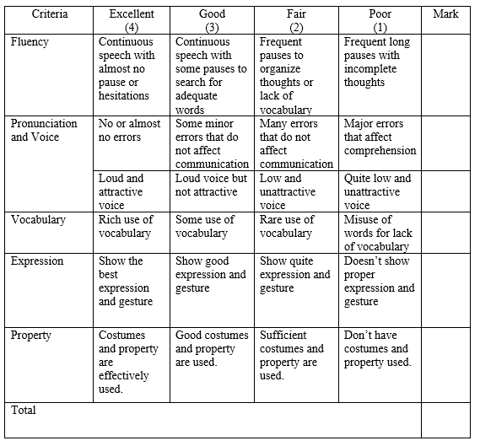

GRADING SYSTEM COMPONENTS

Attendance | : | 10 %
Assignments | : | 20 %
Mid-Term Test | : | 30 %
Final Test | : | 40 %

Approved by,  Head of Study Program  Esa Unggul University  Prayogo Hadi Sulistio, M. Pd. |  |  | Jakarta, September 2018  Lecturer,  Noni Agustina, M. Pd.

