COURSE PROGRAM OF ACADEMIC YEAR 2018/2019
ENGLISH LANGUAGE EDUCATION DEPARTMENT
ESA UNGGUL UNIVERSITY
Course |  | : | Intermediate Reading |  |  | Course Code | : | PBI-364
Prerequisite |  | : | - |  |  | Credit | : | 3 SKS
Lecturer |  | : | Noni Agustina, M.Pd. |  |  | Lecturer Code | : | 7218
Time Allocation |  | : | 2 x 50 minutes
Learning Objectives |  | : | After completing this course, students are expected to be able to report their reading, recognize main idea and supporting details of longer texts, apply the reading techniques (scanning and skimming for longer texts), implement some reading strategies such as guessing from the context, predicting, make the inferences and draw conclusion and make a short article from their reading activities.
WEEK | LEARNING OUTCOMES | TOPIC/SUB-TOPICS |  | LEARNING METHOD AND MEDIA | REFERENCES |  | INDICATOR FOR ASSESSMENT
1 | Students are able to elaborate the course outline and the class regulations | - Course outline  - Class regulations |  | Method: Lecturing and discussion  Media: Projector and whiteboard | Course Outline |  | Students’ comprehension to explain course outline
2 | Students are able to report their pleasure reading | Reading for pleasure |  | Method: Lecturing, discussion, demonstration  Media: Projector, whiteboard, and realia | - Kirn, Elaine and Pamela Hartmann. (2002) Interaction 2 Reading. Fourth Edition. NY: McGraw-Hill Contemporary  - Langan, John. (1992). Reading and study skills. Fifth Edition. USA: McGraw-Hill Inc.  - Mikulecky, Beatrice S. and Linda Jeffries. (1998). Reading power. Second edition. NY: Pearson Education.  - Wegmann, Brenda and Miki Knezevic. (2002). Mosaic 1 Reading. Fourth edition. NY:McGraw-Hill Contemporary |  | Students’ report of reading pleasure
3 | Students are able to recognize main idea and supporting sentences | Main idea and supporting sentences |  | Method: Presentation, lecturing, discussion, demonstration  Media: Projector, whiteboard, and video | - Kirn, Elaine and Pamela Hartmann. (2002) Interaction 2 Reading. Fourth Edition. NY: McGraw-Hill Contemporary  - Langan, John. (1992). Reading and study skills. Fifth Edition. USA: McGraw-Hill Inc.  - Mikulecky, Beatrice S. and Linda Jeffries. (1998). Reading power. Second edition. NY: Pearson Education.  - Wegmann, Brenda and Miki Knezevic. (2002). Mosaic 1 Reading. Fourth edition. NY:McGraw-Hill Contemporary |  | Students’ worksheet to identify the main idea and supporting sentences
4 | Students are able to do the scanning the longer texts. | Scanning |  | Method: Presentation, lecturing, discussion, demonstration  Media: Projector, whiteboard, and video | - Kirn, Elaine and Pamela Hartmann. (2002) Interaction 2 Reading. Fourth Edition. NY: McGraw-Hill Contemporary  - Langan, John. (1992). Reading and study skills. Fifth Edition. USA: McGraw-Hill Inc.  - Mikulecky, Beatrice S. and Linda Jeffries. (1998). Reading power. Second edition. NY: Pearson Education.  - Wegmann, Brenda and Miki Knezevic. (2002). Mosaic 1 Reading. Fourth edition. NY:McGraw-Hill Contemporary |  | Students’ worksheet to scan the longer text
5 | Students are able to do the skimming the longer texts. | Skimming |  | Method: Presentation, lecturing, discussion, demonstration  Media: Projector, whiteboard, and video | - Kirn, Elaine and Pamela Hartmann. (2002) Interaction 2 Reading. Fourth Edition. NY: McGraw-Hill Contemporary  - Langan, John. (1992). Reading and study skills. Fifth Edition. USA: McGraw-Hill Inc.  - Mikulecky, Beatrice S. and Linda Jeffries. (1998). Reading power. Second edition. NY: Pearson Education.  - Wegmann, Brenda and Miki Knezevic. (2002). Mosaic 1 Reading. Fourth edition. NY:McGraw-Hill Contemporary |  | Students’ worksheet to do the skimming the longer text
6 | Students are able to guess the meaning from the context | Guess meaning from the context |  | Method: Presentation, lecturing, discussion, demonstration  Media: Projector, whiteboard, and video | - Kirn, Elaine and Pamela Hartmann. (2002) Interaction 2 Reading. Fourth Edition. NY: McGraw-Hill Contemporary  - Langan, John. (1992). Reading and study skills. Fifth Edition. USA: McGraw-Hill Inc.  - Mikulecky, Beatrice S. and Linda Jeffries. (1998). Reading power. Second edition. NY: Pearson Education.  - Wegmann, Brenda and Miki Knezevic. (2002). Mosaic 1 Reading. Fourth edition. NY:McGraw-Hill Contemporary |  | Students’ worksheet to guess the meaning from the context
7 | Students are able to recognize pronoun and synonym of the longer text. | Pronoun and synonym |  | Method: Presentation, lecturing, discussion, demonstration  Media: Projector, whiteboard, and video | - Kirn, Elaine and Pamela Hartmann. (2002) Interaction 2 Reading. Fourth Edition. NY: McGraw-Hill Contemporary  - Langan, John. (1992). Reading and study skills. Fifth Edition. USA: McGraw-Hill Inc.  - Mikulecky, Beatrice S. and Linda Jeffries. (1998). Reading power. Second edition. NY: Pearson Education.  - Wegmann, Brenda and Miki Knezevic. (2002). Mosaic 1 Reading. Fourth edition. NY:McGraw-Hill Contemporary |  | Students’ worksheet to recognize the pronoun and synonym of the longer text
8 | Students are able to predict the events in a narrative | Predict the events |  | Method: Presentation, lecturing, discussion, demonstration  Media: Projector and whiteboard | - Kirn, Elaine and Pamela Hartmann. (2002) Interaction 2 Reading. Fourth Edition. NY: McGraw-Hill Contemporary  - Langan, John. (1992). Reading and study skills. Fifth Edition. USA: McGraw-Hill Inc.  - Mikulecky, Beatrice S. and Linda Jeffries. (1998). Reading power. Second edition. NY: Pearson Education.  - Wegmann, Brenda and Miki Knezevic. (2002). Mosaic 1 Reading. Fourth edition. NY:McGraw-Hill Contemporary |  | Students’ worksheet to predict the events in a narrative
MID-TERM TEST
9 | Students are able to identify the positive and negative points | Positive and negative points |  | Method: Presentation, lecturing and discussion  Media: Projector and whiteboard | - Kirn, Elaine and Pamela Hartmann. (2002) Interaction 2 Reading. Fourth Edition. NY: McGraw-Hill Contemporary  - Langan, John. (1992). Reading and study skills. Fifth Edition. USA: McGraw-Hill Inc.  - Mikulecky, Beatrice S. and Linda Jeffries. (1998). Reading power. Second edition. NY: Pearson Education.  - Wegmann, Brenda and Miki Knezevic. (2002). Mosaic 1 Reading. Fourth edition. NY:McGraw-Hill Contemporary |  | Students’ performance to identify the positive and negative points
10 | Students are able to make comparison and contrast | Comparison and contrast |  | Method: Presentation, lecturing, discussion, demonstration  Media: Projector, pictures, and whiteboard | - Kirn, Elaine and Pamela Hartmann. (2002) Interaction 2 Reading. Fourth Edition. NY: McGraw-Hill Contemporary  - Langan, John. (1992). Reading and study skills. Fifth Edition. USA: McGraw-Hill Inc.  - Mikulecky, Beatrice S. and Linda Jeffries. (1998). Reading power. Second edition. NY: Pearson Education.  - Wegmann, Brenda and Miki Knezevic. (2002). Mosaic 1 Reading. Fourth edition. NY:McGraw-Hill Contemporary |  | Students’ worksheet to make the comparison and contrast
11 | Students are able to interpret the charts | Interpret the charts |  |  | - Kirn, Elaine and Pamela Hartmann. (2002) Interaction 2 Reading. Fourth Edition. NY: McGraw-Hill Contemporary  - Langan, John. (1992). Reading and study skills. Fifth Edition. USA: McGraw-Hill Inc.  - Mikulecky, Beatrice S. and Linda Jeffries. (1998). Reading power. Second edition. NY: Pearson Education.  - Wegmann, Brenda and Miki Knezevic. (2002). Mosaic 1 Reading. Fourth edition. NY:McGraw-Hill Contemporary |  | Students’ worksheet to interpret the charts
12 | Students are able to make inferences and draw conclusion | Make inferences and draw conclusion |  | Method: Presentation, lecturing, discussion, demonstration  Media: Projector, recorder, video and whiteboard | - Kirn, Elaine and Pamela Hartmann. (2002) Interaction 2 Reading. Fourth Edition. NY: McGraw-Hill Contemporary  - Langan, John. (1992). Reading and study skills. Fifth Edition. USA: McGraw-Hill Inc.  - Mikulecky, Beatrice S. and Linda Jeffries. (1998). Reading power. Second edition. NY: Pearson Education.  - Wegmann, Brenda and Miki Knezevic. (2002). Mosaic 1 Reading. Fourth edition. NY:McGraw-Hill Contemporary |  | Students’ worksheet to make inferences and draw conclusion
13 | Students are able to make a paraphrasing | Paraphrasing |  | Method: Presentation, lecturing, discussion, demonstration  Media: Projector, recorder, video and whiteboard | - Kirn, Elaine and Pamela Hartmann. (2002) Interaction 2 Reading. Fourth Edition. NY: McGraw-Hill Contemporary  - Langan, John. (1992). Reading and study skills. Fifth Edition. USA: McGraw-Hill Inc.  - Mikulecky, Beatrice S. and Linda Jeffries. (1998). Reading power. Second edition. NY: Pearson Education.  - Wegmann, Brenda and Miki Knezevic. (2002). Mosaic 1 Reading. Fourth edition. NY:McGraw-Hill Contemporary |  | Students’ worksheet to make a paraphrasing
14 | Students are able to make a short article | Making short article |  | Method: Presentation, lecturing, discussion, demonstration  Media: Projector, recorder, video and whiteboard | - Kirn, Elaine and Pamela Hartmann. (2002) Interaction 2 Reading. Fourth Edition. NY: McGraw-Hill Contemporary  - Langan, John. (1992). Reading and study skills. Fifth Edition. USA: McGraw-Hill Inc.  - Mikulecky, Beatrice S. and Linda Jeffries. (1998). Reading power. Second edition. NY: Pearson Education.  - Wegmann, Brenda and Miki Knezevic. (2002). Mosaic 1 Reading. Fourth edition. NY:McGraw-Hill Contemporary |  | Students’ work in making a short article
FINAL TEST

ASSESSMENT

WEEK | PROCEDURE | FORM | SCORE > 77  ( A / A-) | SCORE> 65  (B- / B / B+ ) | SCORE > 60  (C / C+ ) | SCORE> 45  ( D ) | SCORE < 45  ( E ) | WEIGHT
1 | Understand the course outline and class regulation |  |  |  |  |  |  | 0
2 | Performance assessment | Report | * See rubric | * See rubric | * See rubric | * See rubric | * See rubric | 5 %
3 | Written assessment | Essay item | * See rubric | * See rubric | * See rubric | * See rubric | * See rubric | 5 %
4 | Written assessment | Essay item | * See rubric | * See rubric | * See rubric | * See rubric | * See rubric | 5 %
5 | Written assessment | Essay item | * See rubric | * See rubric | * See rubric | * See rubric | * See rubric | 5 %
6 | Written assessment | Essay item | * See rubric | * See rubric | * See rubric | * See rubric | * See rubric | 5 %
7 | Written assessment | Essay item | * See rubric | * See rubric | * See rubric | * See rubric | * See rubric | 5 %
8 | Written assessment | Essay item | * See rubric | * See rubric | * See rubric | * See rubric | * See rubric | 5 %
9 | Performance assessment | Presentation | * See rubric | * See rubric | * See rubric | * See rubric | * See rubric | 5 %
10 | Written assessment | Essay item | * See rubric | * See rubric | * See rubric | * See rubric | * See rubric | 5 %
11 | Written assessment | Essay item | * See rubric | * See rubric | * See rubric | * See rubric | * See rubric | 5 %
12 | Written assessment | Essay item | * See rubric | * See rubric | * See rubric | * See rubric | * See rubric | 5 %
13 | Written assessment | Essay item | * See rubric | * See rubric | * See rubric | * See rubric | * See rubric | 10 %
14 | Written assessment | Essay item | * See rubric | * See rubric | * See rubric | * See rubric | * See rubric | 35 %

Assessment Rubric
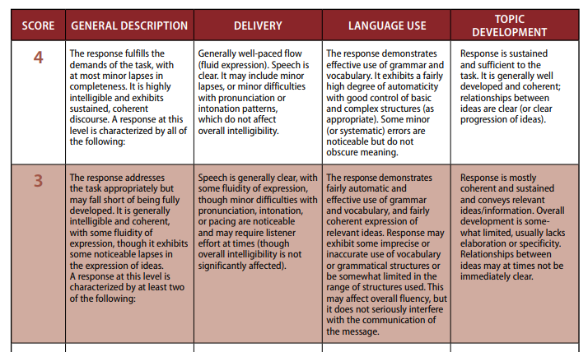

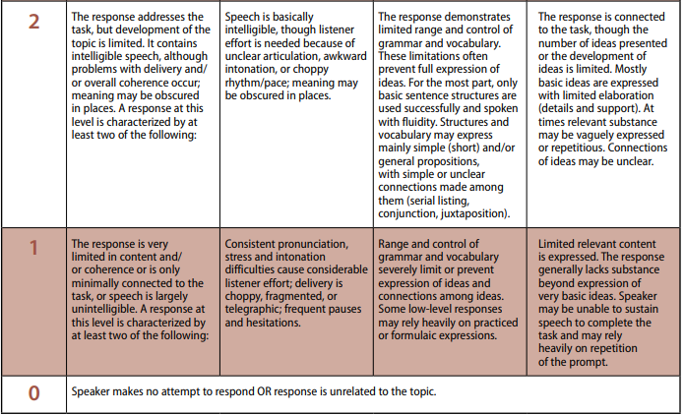

https://www.ets.org/s/toefl/pdf/toefl_speaking_rubrics.pdf

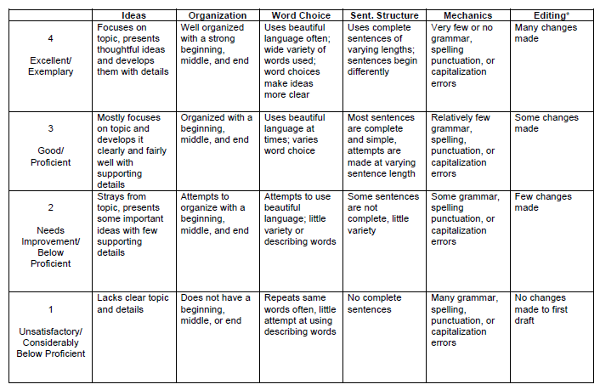

https://www.learner.org/workshops/middlewriting/images/pdf/W5LS-M-Rubric.pdf

GRADING SYSTEM COMPONENTS

Attendance | : | 10 %
Assignments and class participation | : | 20 %
Mid-Term Test | : | 30 %
Final Test | : | 40 %

Approved by,  Head of Study Program  Esa Unggul University  Prayogo Hadi Sulistio, M. Pd. |  |  | Jakarta, September 2018  Lecturer,  Noni Agustina, M. Pd.

